The Big Pig
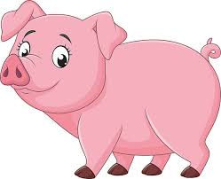
I have a pink pig.
His name is Fig.
Fig the pig is big.
He likes to dig and do a jig.
The big pig digs and digs.

