Name: _______________________________
Number (N) | Patterns & Relations (PR) | Space & Shape (SS)
I can count by 1s starting anywhere from 1 to 10 and from 10 to 1, forwards and backwards. (N1)  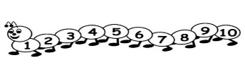  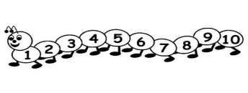 | I know what a repeating pattern is. (PR1)  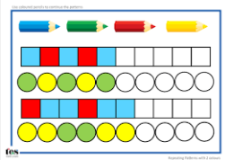 | I can look at two objects and see how they are the same or different in how long they are. (SS1)
I can look at a group of 1 to 5 objects or dots and name how many there are in the group. (N2)  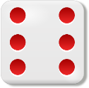  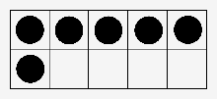  6 | I can look at a pattern and know that it is repeating pattern. (PR1)  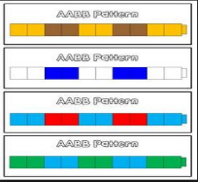 | I can look at two objects and see how they are the same or different in how heavy or light they are. (SS1)
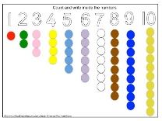  I can match any numeral from 1 to 10 with what it means. (N3) | I can make my own repeating pattern. (PR1) | I can look at two objects and see how they are the same or different in how much they can hold. (SS1)
I can use pictures and words to show what a number means. (N4)  Whole  Part  Part  Whole  Part  Part | I can take a repeating pattern and add more to it. (PR1) | I can pick out objects based on colour, size, shape, corners, movement, and if it can be used with another object to make the same shape. (SS2 & SS3)
I can compare numbers from 1 to 10. (N5)  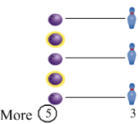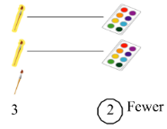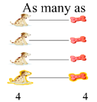 | I can make patterns with objects, sounds, and actions. (PR1)  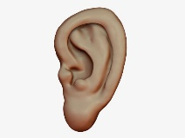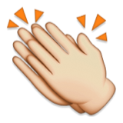 | I can make a 3-D shape. (SS3)
 |  | I can say how an object is 3-D (e.g. big, little, round, like a box, like a can). (SS3)

